**Best Buy Sales Database**

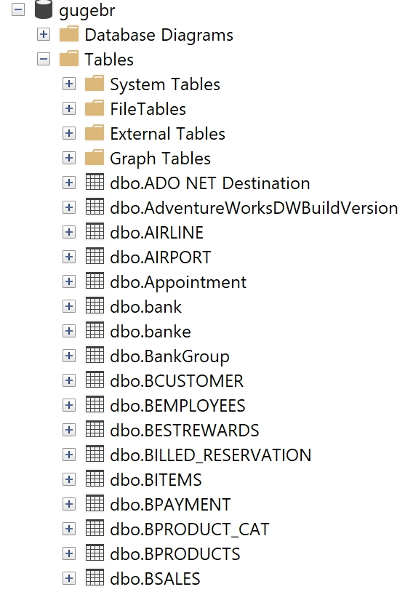

By: Brett Gugel

Created On: 4/26/2023.

**Company Overview**

Best Buy is a Multinational electronics retail Company based in the United States. They sell a wide range of electronics, furniture, video games and accessories. Best Buy’s brick and mortar locations serve customers who intend to pay in cash and card. People shopping at Best Buy earn points for every 100 dollars spent that they could redeem for free promotional items.

**Requirements**

* Each customer must have a unique first and last name, phone number, rewards account, and email.
* A customer can make one or more purchases.
* A customer must have a reward account.
* A Customer can have multiple payments on file.
* A Customer must have one or more active payment methods to open a sale.
* Accepted Payments include Cash, Visa, MasterCard, Discover, AmExpress
* A Sale can have one or multiple products.
* Each sale must have a customer and an employee.
* To complete a sale, a customer’s payment cannot be expired.
* Each Product and Product Subcategory must have a unique name.

**E-R Model**

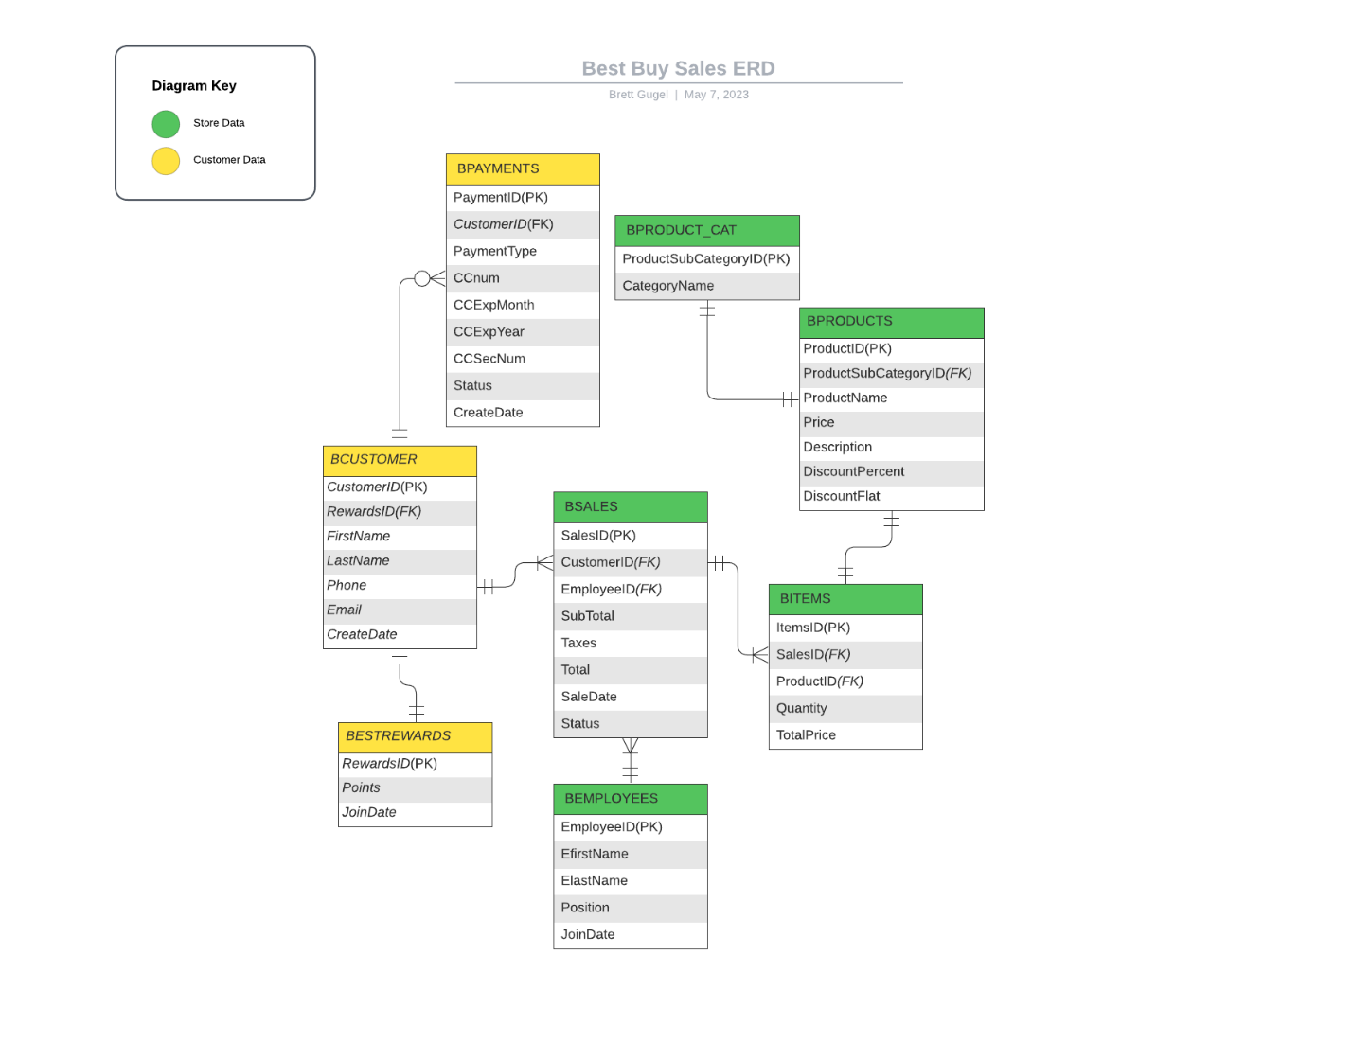

**Database Implementation:**

Tables must be created in the following order.

* + BESTREWARDS
  + BCUSTOMER
  + BPAYMENT
  + BPAYMENT_CAT
  + BEMPLOYEES
  + BPRODUCTS
  + BSALES
  + BITEMS

**Design Considerations**

• A user of this database would only be given stored procedures to insert data, direct INSERT statements cannot be given to an end user.

• A customer must be associated with a Best rewards account so a customer’s purchases can earn them points, A Customer can be created without an associated payment, but they would need to create one before they can open or close a sale.

• A customer can have multiple payment methods, payment cards that are expired cannot be added to the database, and when a card expires, it will be disabled in the database when a customer tries to close a purchase.

• A BSALES must be created before a customer can add items to BITEMS

• A Sale can remain open as long as a customer would like, but they cannot open a new sale until they close their current one.

• When Items are added to a sale, the total, tax and subtotal values change in the associated BSALES

• When a sale is closed, points are assigned to the customers BESTREWARDS account.

• A customer must pay with ONE of their BPAYMENT options.

**Create Tables**

Create part 1.

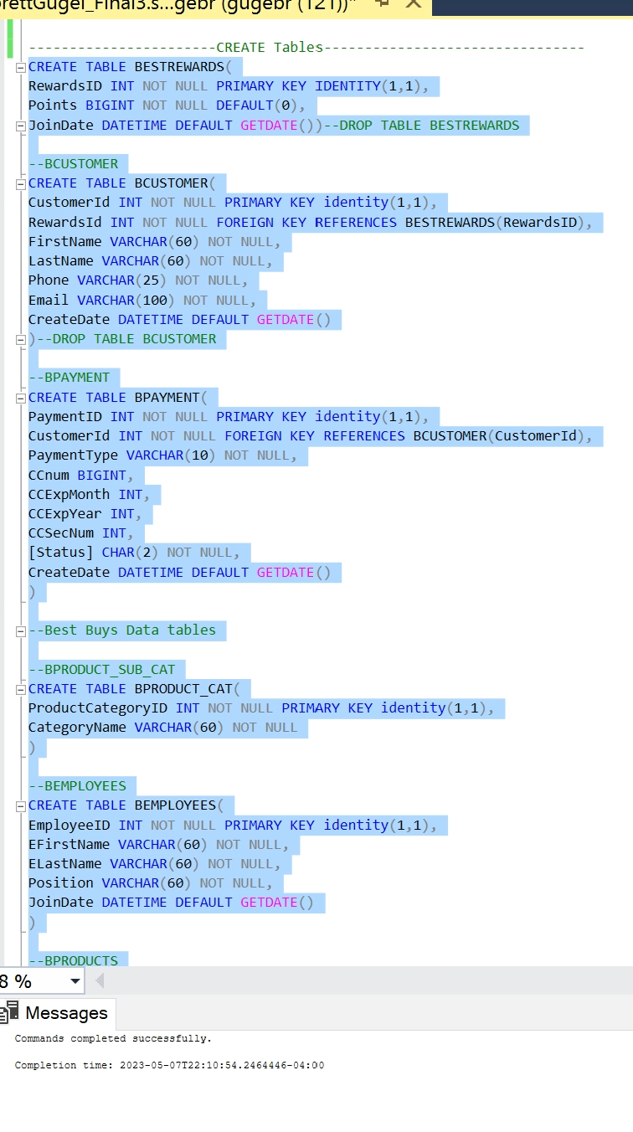

Create part 2

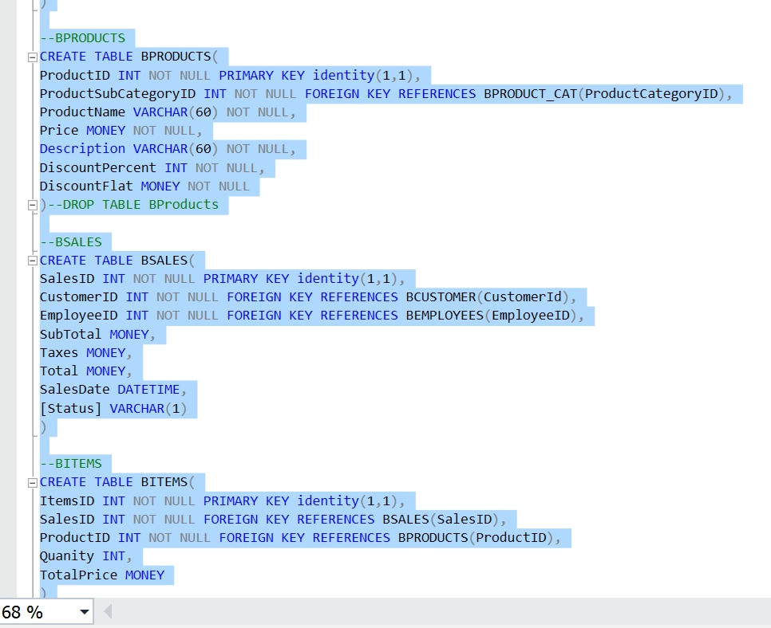

**Insert Data**

Insert into BEST REWARDS AND BCUSTOMER

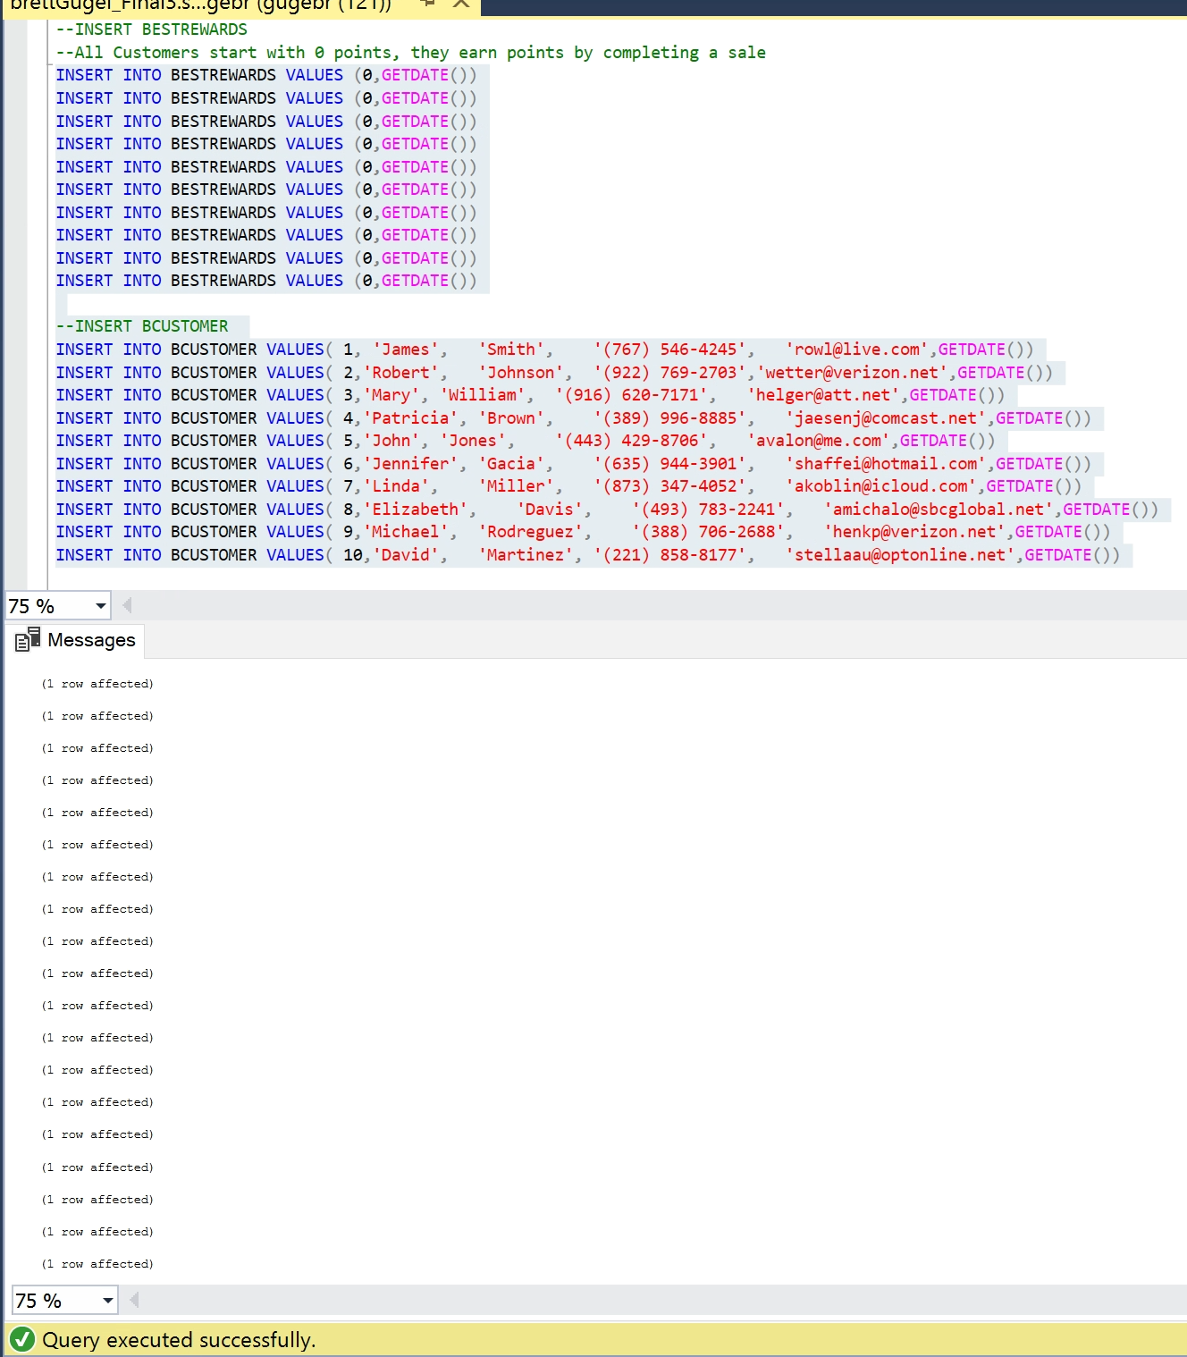

Insert into BEMPLOYEES And BPAYMENT

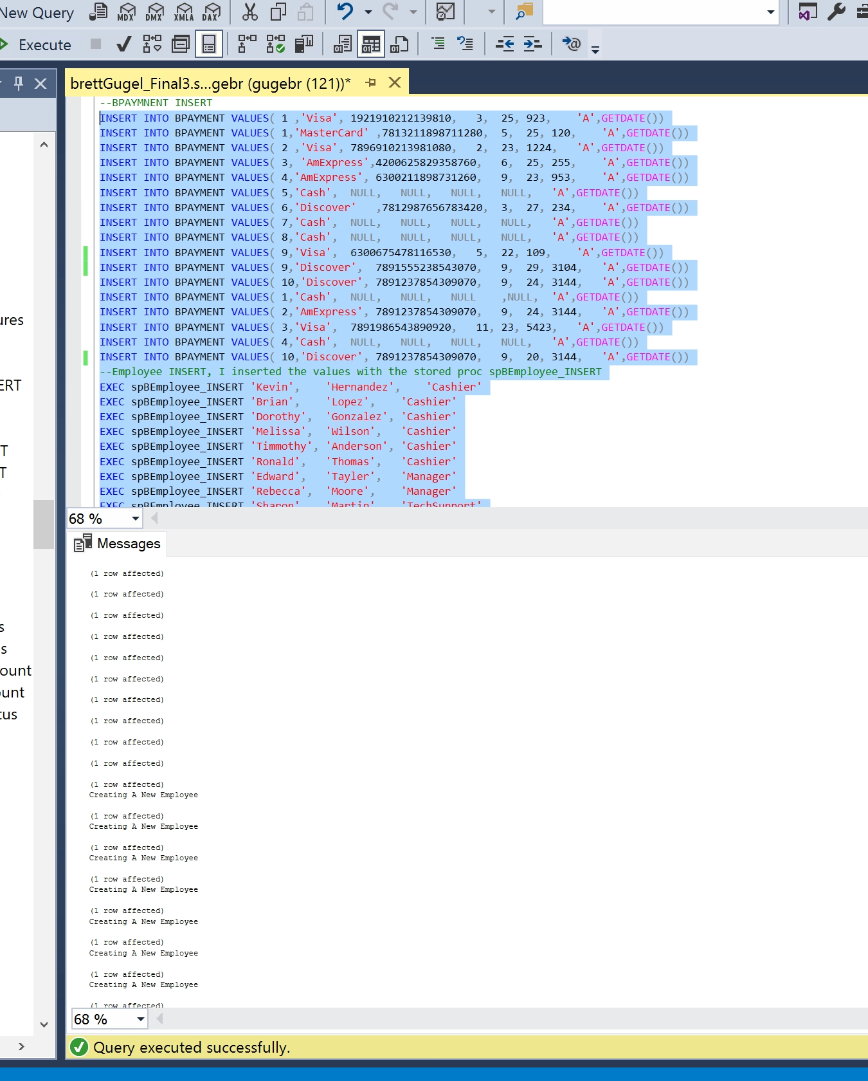

Employee is being created with a Stored Proc that ensures that an employees cannot have duplicate names

Insert into BPRODUCT_CAT and BPRODUCT

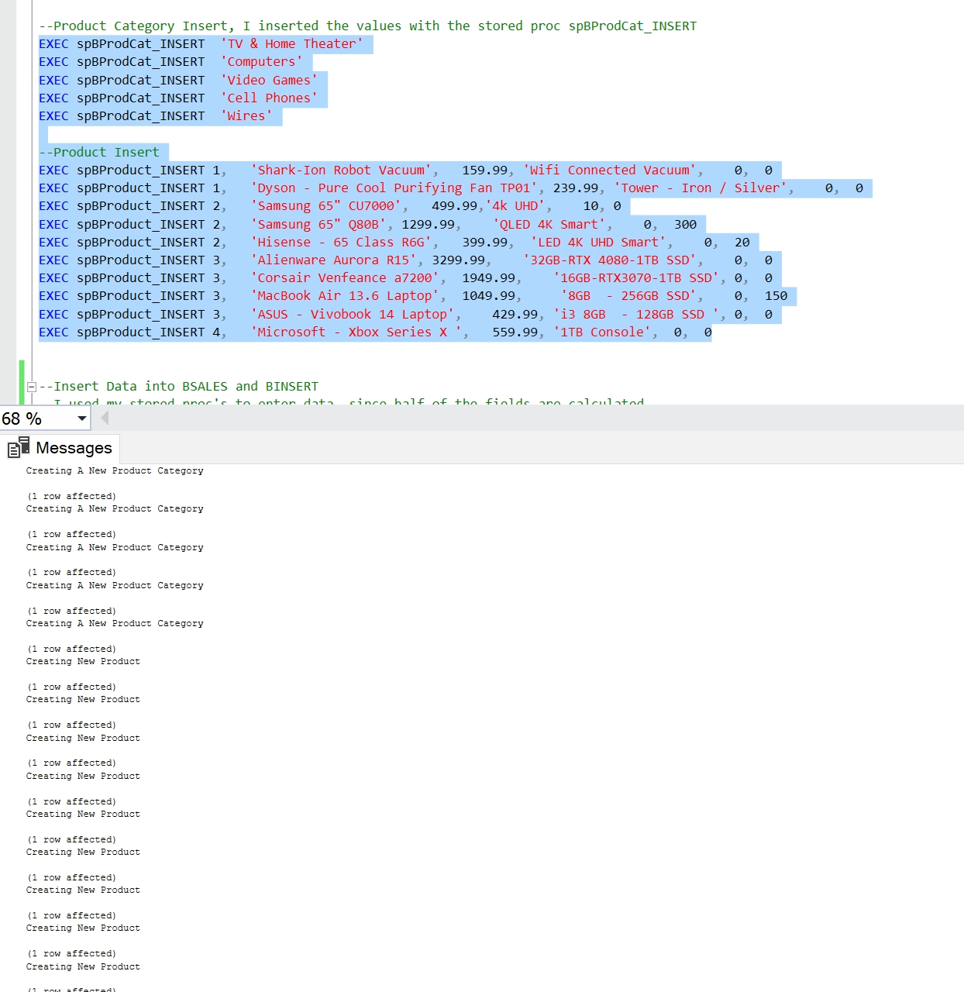

Stored procedures handle new data, ensuring duplicate entries are rejected

Insert BITEMS AND BSALES



**Use/Test Cases**

**Customer**

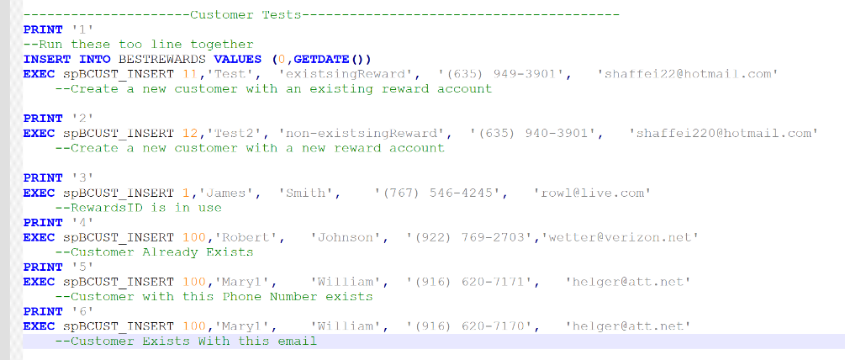

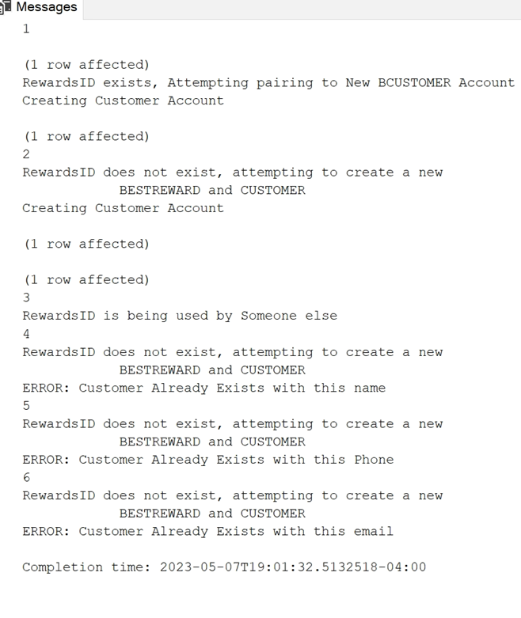

**Payment**

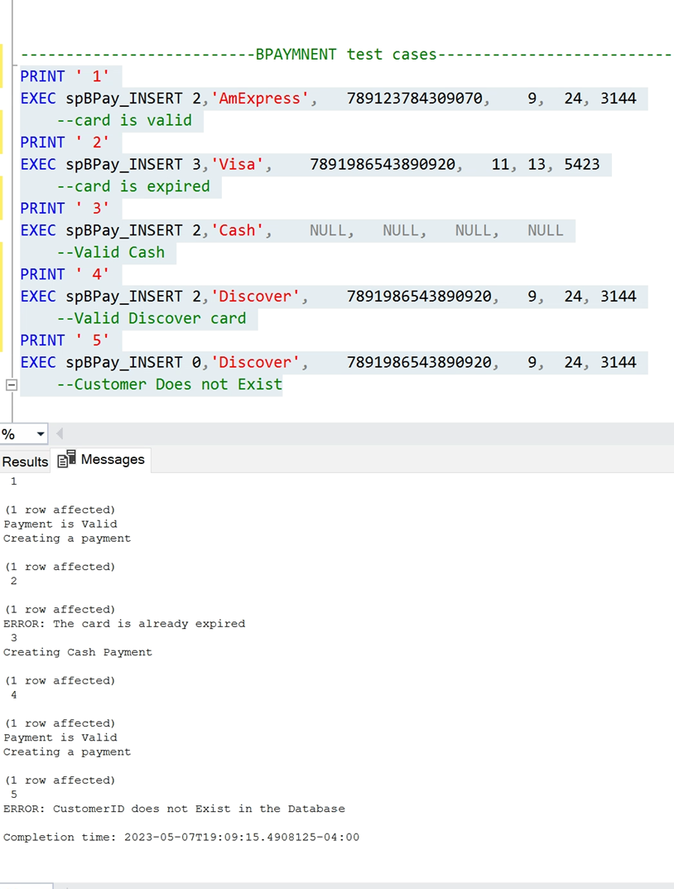

**BEMPLOYEES Tests**

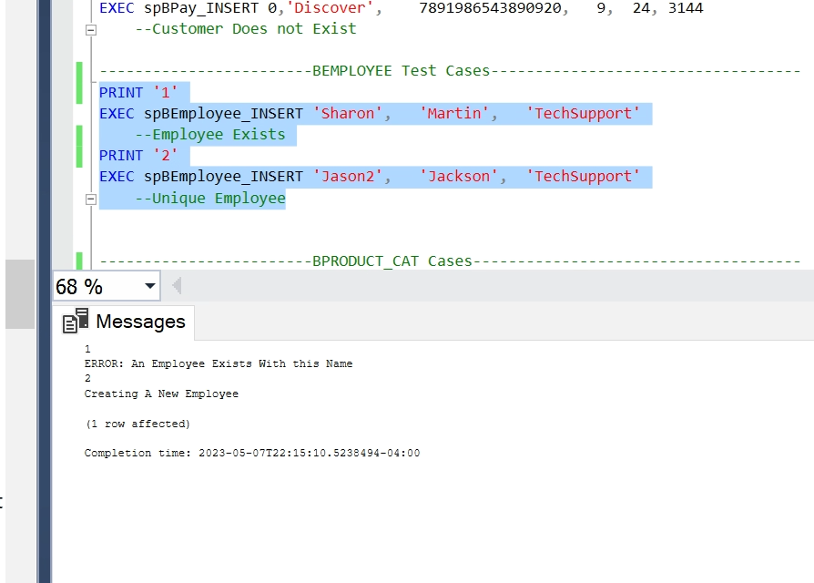

**BPRODUCT_CAT Tests**

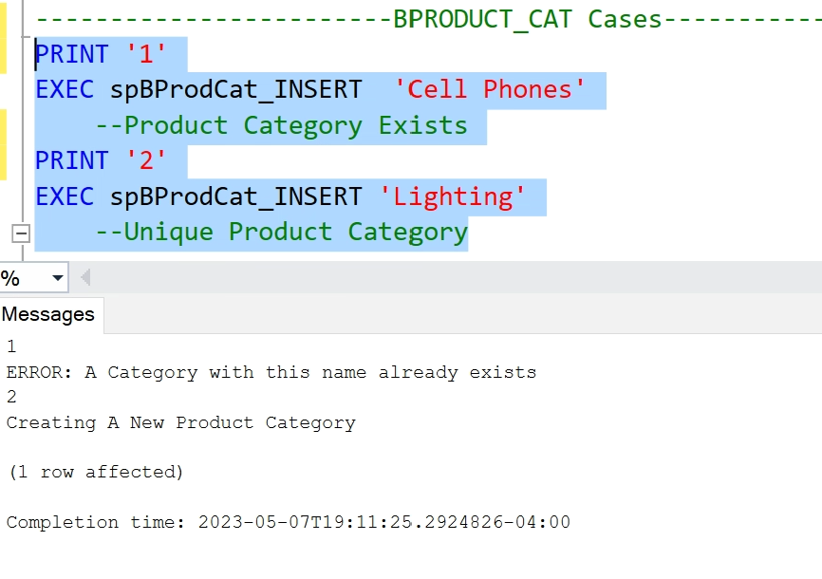

**BPRODUCTS Tests**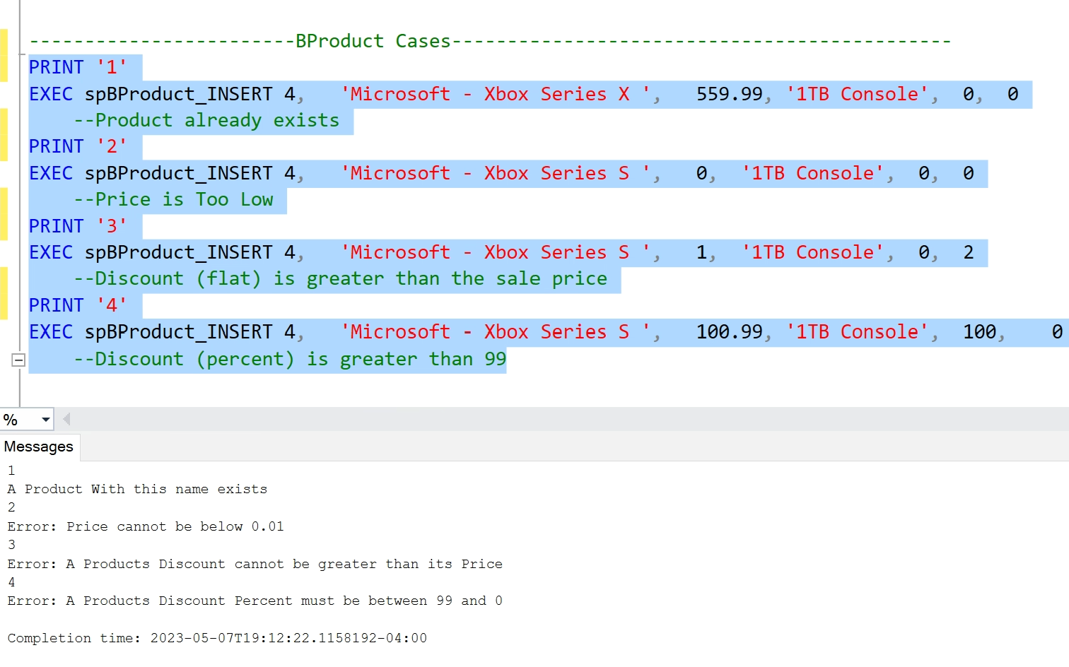

**BSALES/BITEMS**

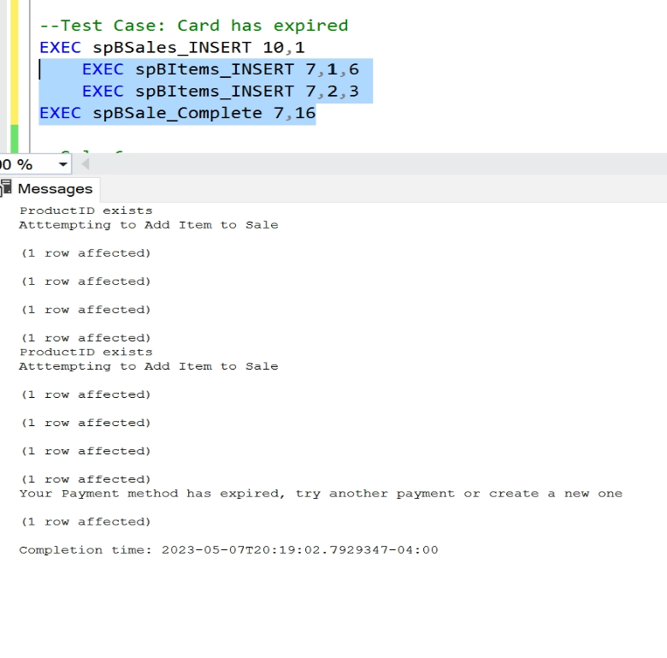

The Customer tried using a payment method that has expired.

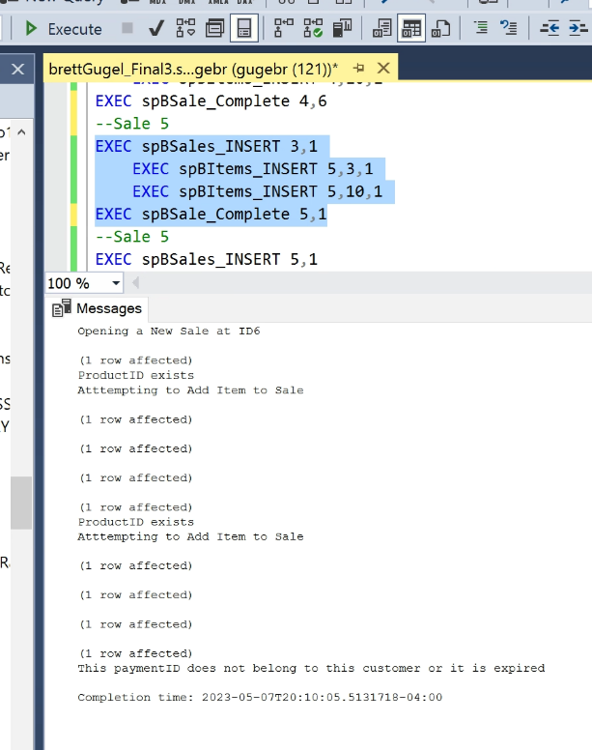

The Customer used a Payment that does not belong to them.

**Solution Design**

Tables Created:

Solution Part 1: BITEMS, BSALES, BPRODUCTS

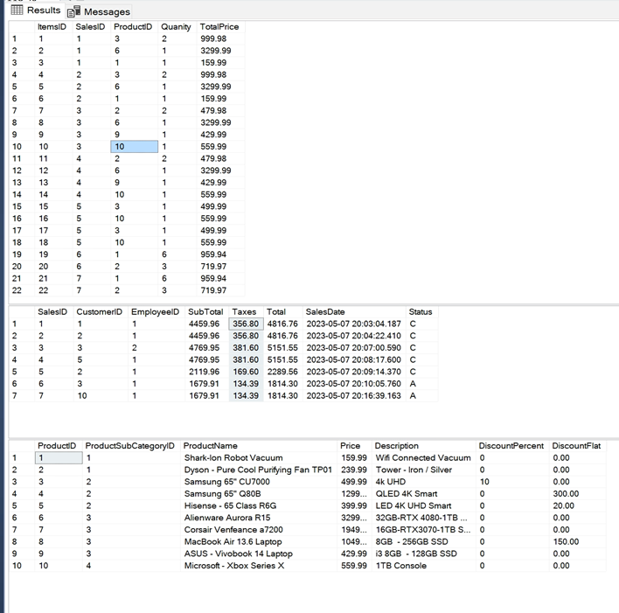

Solution Part 2: BEMPLOYEES, BPRODUCT_CAT, BPAYMENT

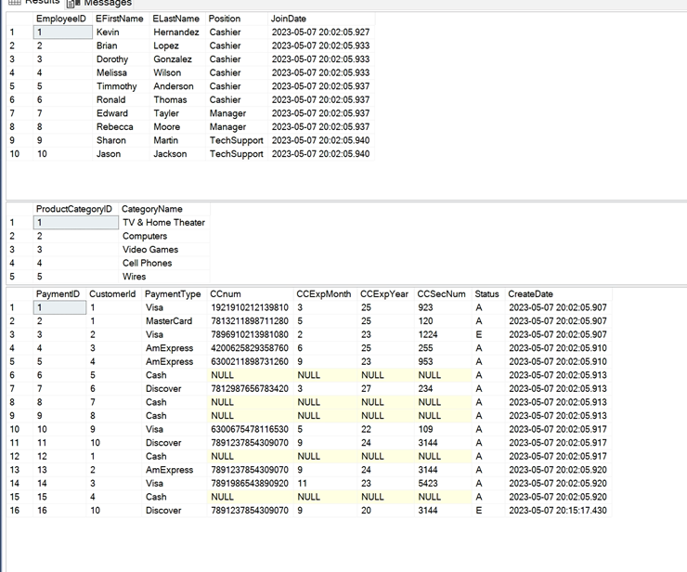

Solution Part 3: BEMPLOYEES, BPRODUCT_CAT, BPAYMENT

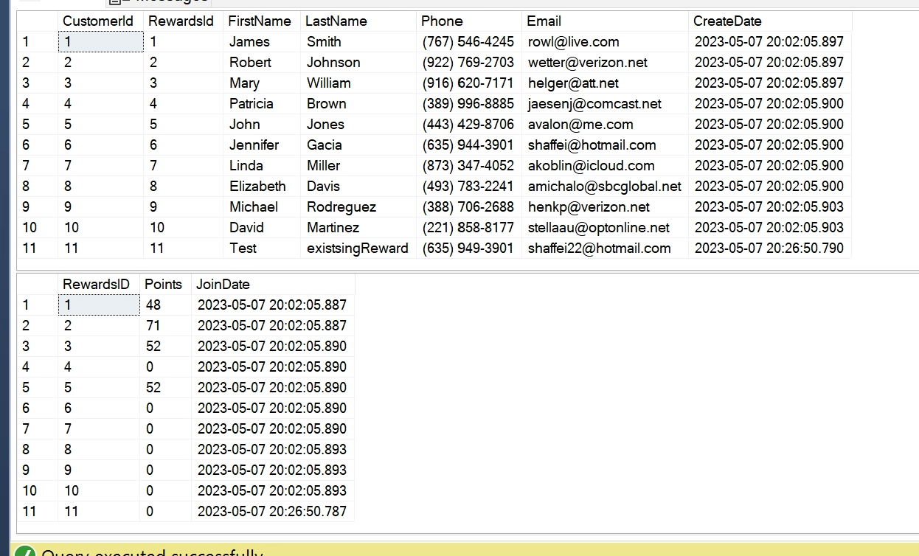

**Database**

